HTML Quick-Styler

AI-Powered HTML Page Generator with IBM Granite 3.3 2B

Project Description:
HTML Quick-Styler is an AI-powered web page generation platform that creates HTML webpages using simple text prompts. This project uses IBM Granite 3.3 2B Instruct model to generate structured HTML and CSS code automatically.
The system analyzes user input such as page title, required sections, and design preferences. Based on this input, the AI model generates semantic HTML structure and applies modern CSS styling with responsive design.
This project is implemented using Python in Google Colab and provides a user-friendly interface using Gradio. The generated HTML code can be copied and executed in any web browser or code editor.
HTML Quick-Styler helps beginners and developers quickly generate webpage layouts without writing complex HTML code manually. It simplifies web development by combining Artificial Intelligence with modern web design principles.

Scenarios:
Scenario 1: Portfolio Website Generation
A freelance designer wants to create a portfolio website quickly.
The system analyzes the designer’s requirements and automatically
generates a webpage structure that includes a hero section, portfolio
gallery, about section, testimonials, contact form, and footer with
social media links. This helps the designer showcase their work in a
professional way.
Scenario 2: SaaS Landing Page
A startup needs a landing page to promote their product. The system
creates a hero banner with the product message, a features section
explaining the product capabilities, a pricing table, and testimonials
to build user trust. Call-to-action buttons are added to encourage
visitors to sign up or purchase the product.
Scenario 3: Corporate Website
A company wants to build a professional corporate website. The system
generates a structured webpage with a navigation header, company
overview section, services grid, team members section, contact
information, and a footer with important links.
Scenario 4: Custom Color Palette Exploration
A designer wants to experiment with different color schemes. The system
generates multiple color palettes such as modern, vibrant, ocean, and
minimal themes. Each palette includes hex color codes and ensures
consistent color usage across the webpage design.

Architecture Overview:

HTML Quick-Styler is developed as a modular system that combines a Python backend with the IBM Granite 3.3 2B Instruct model to generate HTML webpages automatically. The system analyzes user input and produces structured HTML and CSS code.

The platform uses Gradio to provide a simple and interactive user interface where users can enter prompts describing the webpage they want to generate. Based on the prompt, the AI model creates a responsive webpage layout with proper sections and styling.

The system is implemented in Google Colab and follows modern web development standards such as HTML5, CSS3, and responsive design principles to ensure the generated webpages work across different devices.

Core Technologies:

• Python 3.x – Core programming language used for application logic

• IBM Granite 3.3 2B Instruct – AI model used for HTML generation

• Gradio – Interactive interface for user input and output display

• HTML5 and CSS3 – Web technologies used to generate webpages

• JavaScript – Used for basic interactivity

• Google Colab – Cloud-based environment used to run the project

• Responsive Design – Ensures webpages work on mobile and desktop devices.

Software Requirements

• Python 3.x – Programming language used for the project

• Google Account – Required to access Google Colab

• Gradio Library – Used to create the interactive interface

• Web Browser – Chrome, Firefox, or Edge for accessing the application

• Internet Connection – Required for running the project in Google Colab

Knowledge Prerequisites:

• Basic knowledge of Python programming

• Basic understanding of HTML and CSS

• Familiarity with Google Colab environment

• Basic understanding of web design concepts

Hardware Requirements:
• Processor – Intel i3 or equivalent
• RAM – Minimum 4GB
• Storage – At least 1GB free space
• Display – Minimum 1280 × 720 resolution
Project Workflow:

Phase 1: Environment Setup & Model Configuration
Establish Google Colab environment and configure Granite model

Activity 1.1: Set up Google Colab Environment
• Create new Google Colab notebook
• Enable GPU runtime for better performance
• Install required Python packages
• Verify environment configuration

Activity 1.2: Configure IBM Granite Model
• Access Hugging Face model repository
• Load Granite 3.3 2B Instruct model
• Test model inference capabilities
• Configure generation parameters

Activity 1.3: Install and Configure Gradio
• Install Gradio via pip
• Test basic Gradio interface
• Configure sharing options
• Verify interface rendering

Phase 2: Core Application Development
Build HTML generation engine and template system

Activity 2.1: Build Color Palette Generator
• Create ColorPaletteGenerator class
• Define 8 color palette schemes
• Implement palette selection logic
• Add color validation methods

Activity 2.2: Implement HTML Page Builder
• Create HTMLPageBuilder class
• Build section detection algorithm
• Implement template generation methods
• Create SEO meta tags generator

Activity 2.3: Develop CSS Generation Engine
• Build comprehensive CSS generator
• Implement responsive design rules
• Add animation and transition effects
• Create mobile-first media queries

Activity 2.4: Build Section Templates
• Create hero section template
• Build features grid template
• Implement portfolio gallery template
• Add contact form template
• Create pricing and testimonial templates

Phase 3: Gradio Interface Development
Create interactive user interface with multiple tabs

Activity 3.1: Interactive HTML Generation & Preview Interface
Activity 3 focuses on designing and implementing a complete HTML generation and visualization interface that enables users to create, customize, preview, and understand web page layouts through an intuitive, multi-section workflow.

Phase 4: Google Colab Deployment:
Integrate all components and perform comprehensive testing

Activity 4.1: End-to-End Integration
• Connect all interface components
• Test data flow between tabs
• Validate generation pipeline
• Test error handling

Phase 5: Deployment & Documentation
Deploy application and create comprehensive documentation

Activity 5.1: Functionality testing
• Configure Gradio sharing settings
• Enable public access link
• Test external access
• Document deployment steps

Technical Architecture:
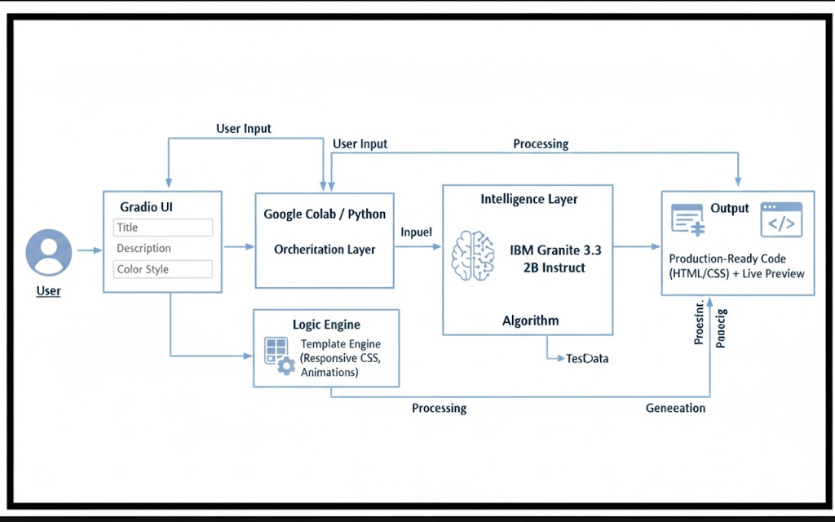

Project Structure:
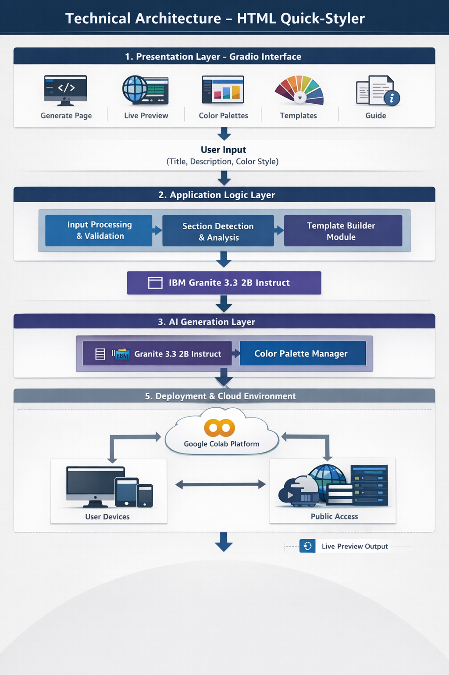

Opening the project in Google Colab:

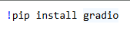

Instaling Required Libraries:
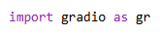

Created HTML generating ChatBot:


Enter the Website Description to the AI HTML Generator:


The AI HTML Generator Code Creation:


Output of the AI HTML Generator Creating Code:
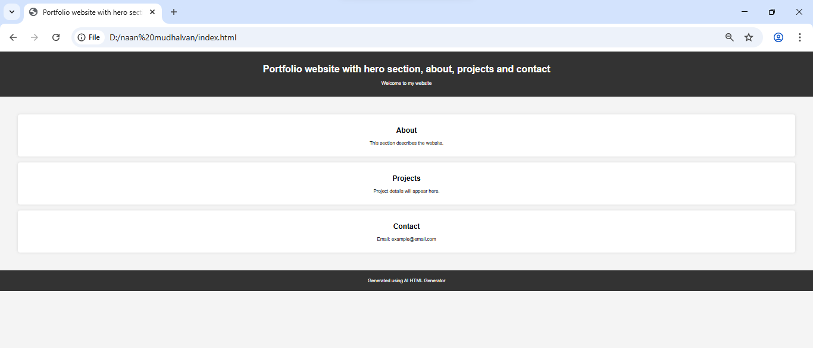

Results / Output:

The HTML Quick-Styler system successfully generates structured HTML

webpages based on user input. The AI model analyzes the prompt provided by the

user and automatically creates webpage layouts with sections such as hero

section, features section, portfolio gallery, testimonials, and contact form.

The generated HTML code follows modern web standards and includes

responsive design so that webpages work properly on both desktop and mobile devices.

Advantages:

• Automatic HTML webpage generation using AI
• Reduces manual coding effort
• User-friendly interface using Gradio
• Generates responsive and modern webpage layouts
• Saves time in web development

Conclusion:
HTML Quick-Styler successfully delivers an intelligent web page generation assistant that combines intuitive design templates with IBM Granite 3.3 2B Instruct model capabilities. By leveraging Gradio's powerful interface framework and Google Colab's cloud infrastructure, the system provides fast, professional, and customizable HTML/CSS generation accessible to designers, developers, and non-technical users alike.
The platform demonstrates the viability of AI-assisted web development, making professional page creation accessible while maintaining high design standards, responsive layouts, and production-ready code quality. With eight distinct color palettes, intelligent section detection, and comprehensive template options, HTML Quick-Styler empowers users to create beautiful websites in minutes rather than hours.
Future enhancements could include custom color picker integration, JavaScript interactivity generation, component library expansion, and integration with popular web frameworks. The modular architecture allows for easy extension and customization to meet evolving user needs and design trends.

Future Enhancements:
• Integration with advanced JavaScript components
• Support for multi-page website generation
• More design templates and themes
• Integration with web hosting platforms

References:
• IBM Granite Model Documentation
• Google Colab Documentation
• HTML5 and CSS3 Web Standards
• Gradio Framework Documentation

